***CREATION OF WINDOWS EC2 INSTANCE USING AWS***

**Architecture:-**

**Explanation:-**

The above image shows the architecture of Windows EC2 Instance that we are going to create. We will Create this EC2 Instance in Asia-Pacific ( Mumbai Region).

Within Mumbai region there are 3 AZ’s as shown in the architecture we will create our EC2 instance in one of the Availability Zone.

**Steps:-**

1. Log into AWS Management Console and Navigate to compute🡪 EC2 Service.

We are now in EC2 Dashboard as shown in below image.

1. Verify the Region in which we want to create the EC2 Instance. Select the correct Region. In our case it is Asia-Pacific (Mumbai) Region.
2. Now Navigate to **Instances** and click on **Create Instance.**

1. Give **Name** to Our Instance.

1. Now **Select the AMI**, in our case it is Windows AMI.

An AMI is a template that contains the software configuration (operating system, application server, and applications) required to launch your instance.

There is total 4 types of AMI category:-

* QuickStart AMI’s🡪 Commonly used AMI.
* My AMI’s 🡪 AMI’s Created By me.
* AWS Marketplace AMI’s 🡪 AWS trusted third party AMI.
* Community AMI’s 🡪 Open AMI Published by Anyone.

Almost all possible OS’s AMI are available in AWS (Linux, Windows, MacOS, etc..).

Click on Select.

Here we are selected Windows server 2019 Base.

1. Next Step is to Select **Instance Type.**

Amazon EC2 provides a wide selection of instance types optimized to fit different use cases. Instance types comprise **varying combinations of CPU, memory, storage, and networking capacity** and give you the flexibility to choose the appropriate mix of resources for your applications.

We can select the best suited pre-defined configuration from pool of available predefined configuration.

1. **Create or Select the Key-Pair**(login)

We  use a key pair to securely connect to your instance. Ensure that you have access to the selected key pair before you launch the instance.

Here we will create a Key pair. Please note that we can use this Key Pair for future instance creation as well Or we can keep create separate Key Pair for each and every Instance.

We can use default available key pair as well, (There will always be one default key pair available in AWS).

Click on “Create Key Pair”.

Note that for windows only **RSA Key Pair type** is available. But for Linux instances along with RSA one more Key Pair Type called **ED25519** is available.

Always save the .pem or .ppk key file in Downloads folder.

Note:- We can only download the key file during Key Pair creation. We cannot download key file later or if we lost this key we can not access the EC2 instances.



1. Next Step is about **Network Settings.**

Click on Edit. To select the VPC, Subnet( Availability Zone), and Security Group.

We Use Default VPC .

For Subnet

We will Select AP-South-1A, if No preference for AZ, AWS automatically choose one of the available AZ.

For Public IP

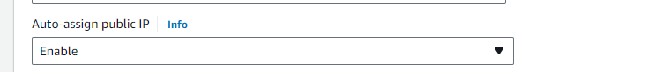

AWS will automatically assign public IP Address here; we can disable auto-assign public Ip to Manually assign Public Ip.

We use public IP Address to access our Instance.

For Security Group (Firewall).

* AWS Security Groups are**virtual firewalls that control the traffic that is allowed to reach and leave resources associated with them**.
* They filter both incoming and outgoing traffic associated with an EC2 instance at the TCP and IP layers, involving specific ports and source/destination IP addresses.
* Security Groups help secure the cloud environment by controlling how traffic will be allowed into EC2 machines.
* Inbound rules control the incoming traffic to the instance, and outbound rules control the outgoing traffic from the instance.

For Windows we use RDP protocol and Fore Linux we use SSH. Keep Source type anywhere so that we can access our instance from anywhere.

We can provide custom IP as well, if we have our own IP we can provide “My IP” as well.

1. **Configure Storage**

Here we configure our root volume.

By default, for windows instance root volume will be 30 GB and for Linux instance root volume will be 8 GB. We can increase the root volume size as well.

Here we can add additional Storage as well if required.

1. Select the **Number of Instances.**

In the right-side pane, under Summary we can give number of instances that we want it will create specified number of instances with the specified configuration.

Note:-If we specify the n =10, that means Number of Instances equal to 10, all the 10 Instances are created in same Availability Zone.

1. Now click on **Launch Instance.**

Now we can see our created instance/s in EC2 Dashboard.

The **status check** field is in **Initializing** state. When we get **status** **check** field as **2/2 checks passed** then our EC2 instance is ready.

**Accessing the created Windows EC2 Instance via RDP Client using Public IP**

Copy the Public IP Address.

Now Click on **Connect.**  Navigate to  **RDP Client.** Now Download the **remote desktop file.** Keep it in the Downloads folder.

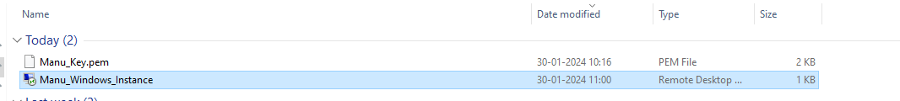

Double click on Downloaded RDP client.

It is connecting to our EC2 instance using Public IP address

Next step is to get password from our key file. Now Go back to AWS Window of our screen. Click on **get password.**

